INSTRUCTIONS: This is an SOP template; it is complete when
1) All form fields have been completed to reflect chemical/lab-specific information, including adding relevant procedure information, or deleted inapplicable information; and
2) SOP has been signed and dated by the PI and relevant lab personnel.
Use safety data sheets (SDSs) as a resource for chemical-specific information. Text highlighted in gray indicates where information should be added or edited. Delete all instructions in red text and “Draft” watermark after the SOP is approved by PI.
Standard Operating Procedure
Trifluoroacetic Acid
Print a copy and insert into your Lab-Specific Chemical Hygiene Plan.

Section 1 – Lab-Specific Information
Building/Room(s) covered by this SOP:
Unit or department:
Principal Investigator Name:
Principal Investigator Signature/Date:
This SOP was created by (if not PI):
Name/Title/Date/Signature
Section 2 – Hazards
Trifluoroacetic acid is a corrosive. It is a triple-fluorinated version of acetic acid and a hundred thousand times stronger than normal acetic acid.
Causes severe burns by all exposure routes and is extremely destructive to tissue of the mucous membranes and upper respiratory tract, eyes, and skin. Fumes can be suffocating. Eye contact causes burns, irritation, and may cause blindness. Contact with skin causes burns and irritation. These burns or blisters may not appear until hours after exposure.
Toxic by ingestion, inhalation, and skin absorption.
Trifluoroacetic acid is often used in peptide synthesis to remove the t-butoxycarbonyl (BOC) protecting group, and in liquid chromatography as an ion pairing agent in the mobile phase.
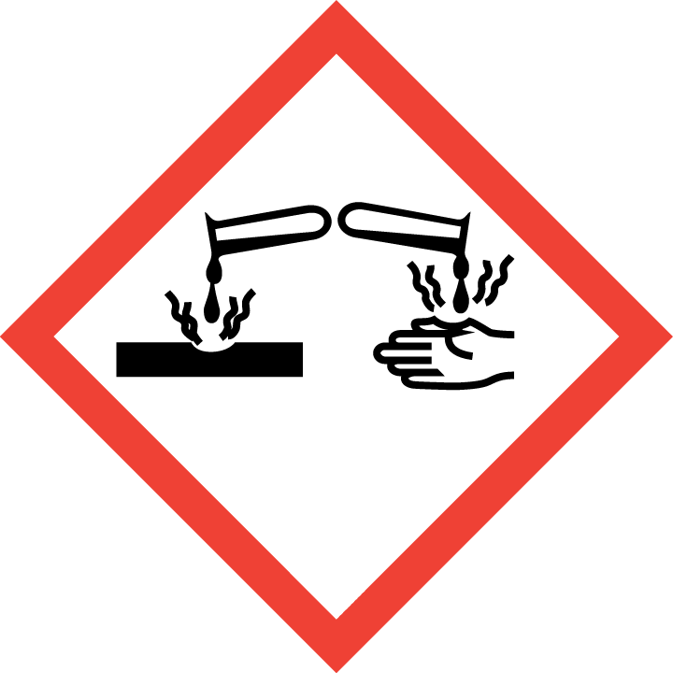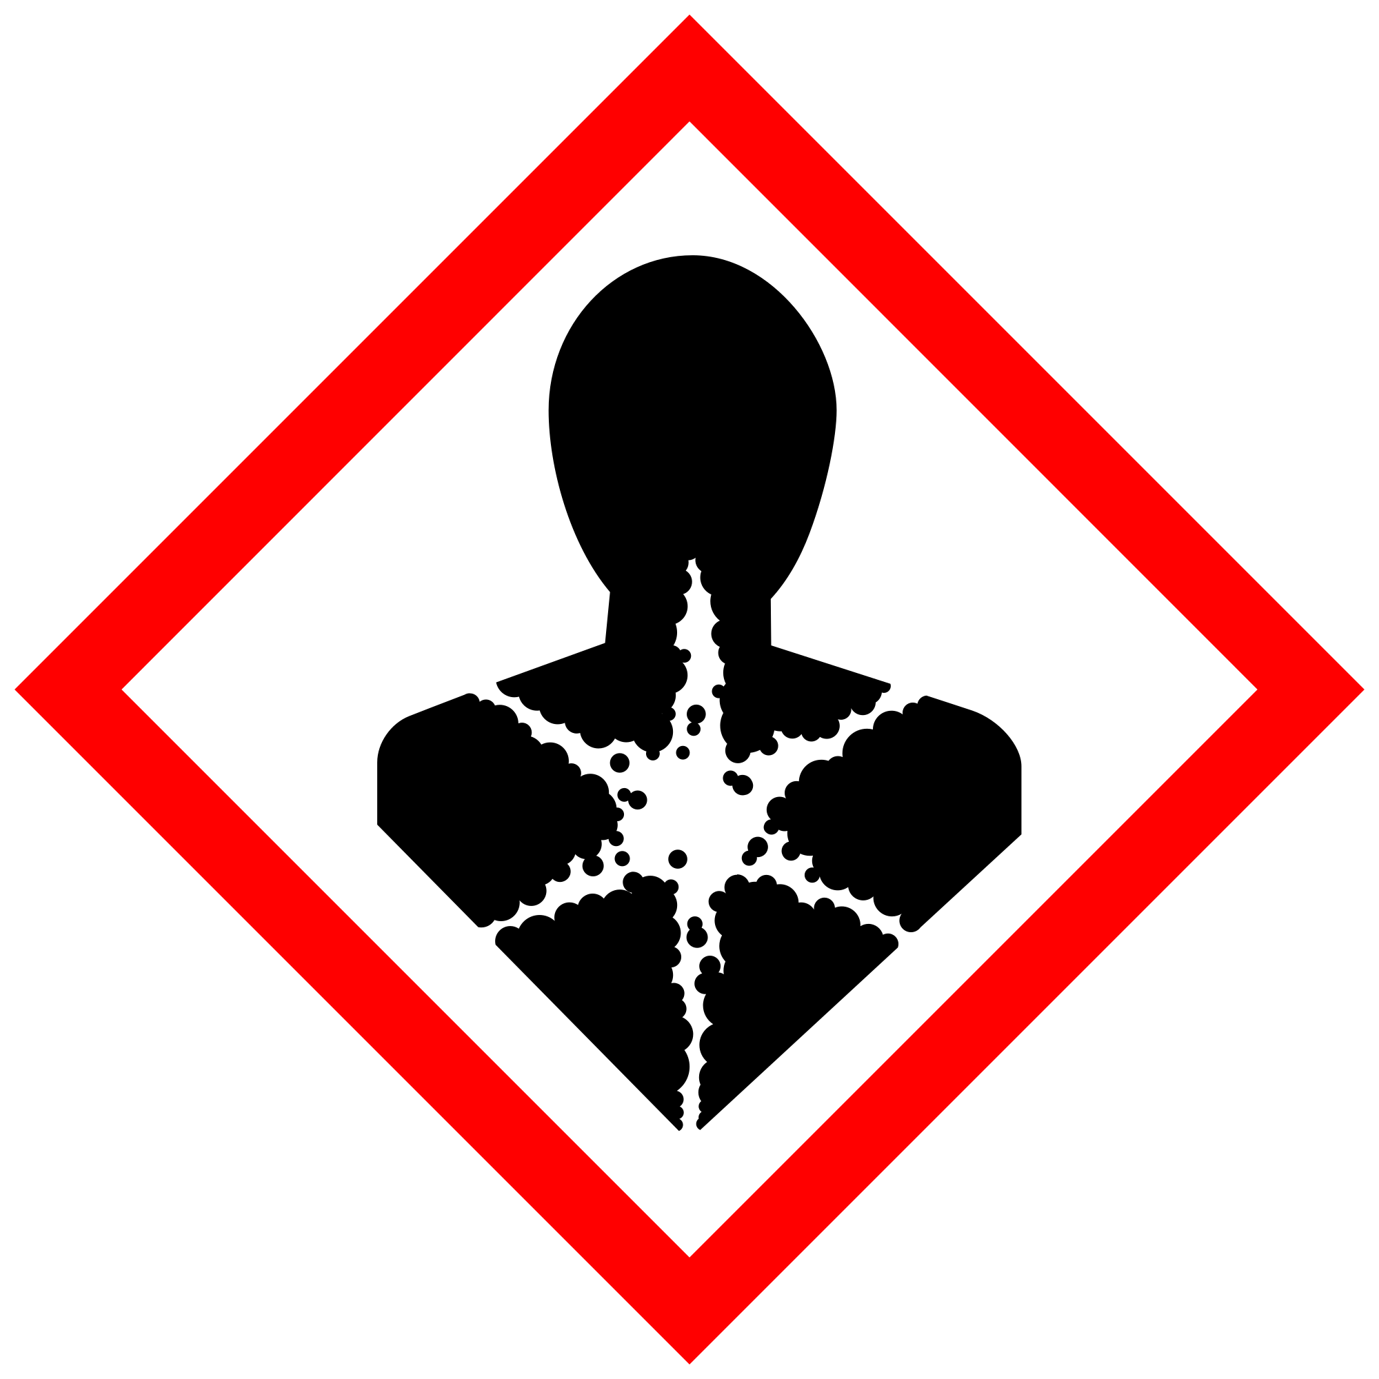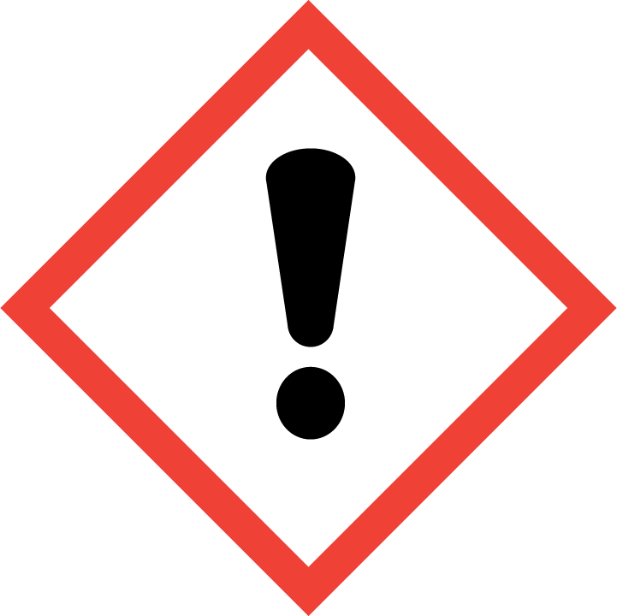
Section 3 – Engineering and Personal Protective Equipment (PPE)
Engineering Controls: Use of Trifluoroacetic acid should be conducted in a properly functioning chemical fume hood whenever possible. The chemical fume hood must be approved for use by EH&S.
Hygiene Measures: Avoid contact with skin, eyes, and clothing. Wash hands before breaks and immediately after handling the product.
Hand Protection: Chemical-resistant gloves must be worn, nitrile gloves are recommended for low volume applications. For high volume (> 500 mL) applications, disposable gloves are not appropriate; a heavy-duty glove is required such as butyl rubber, Viton, or equivalent. NOTE: Consult with your preferred glove manufacturer to ensure that the gloves you plan on using are compatible with the specific chemical being used.
Eye Protection: ANSI approved properly fitting chemical splash goggles are required. A face shield may be required for high volume (> 500 mL) applications.
Skin and Body Protection: Laboratory coats must be worn and be appropriately sized for the individual and buttoned to their full length. For high volume applications (> 500 mL), additional PPE such as a chemical-resistant apron may be required. Personnel must also wear full length pants, or equivalent, and close-toed shoes. Full length pants and close-toed shoes must be worn at all times by all individuals that are occupying the laboratory area. The area of skin between the shoe and ankle must not be exposed.
Respiratory Protection: If Trifluoroacetic acid is being used outside of a chemical fume hood, a full-face respirator may need to be used. If this activity is necessary, contact EH&S at 206.543.7388 so a respiratory protection analysis can be performed.

Section 4 – Special Handling and Storage Requirements
- Do not over purchase; only purchase what can be safely stored in the laboratory.
- Avoid contact with skin and eyes. Avoid inhalation of vapor or mist.
- Always use inside a properly functioning chemical fume hood.
- Note: In case you need to dilute the concentration of acids, always add acid to water.
- Keep container upright and tightly closed in a dry and well-ventilated place.
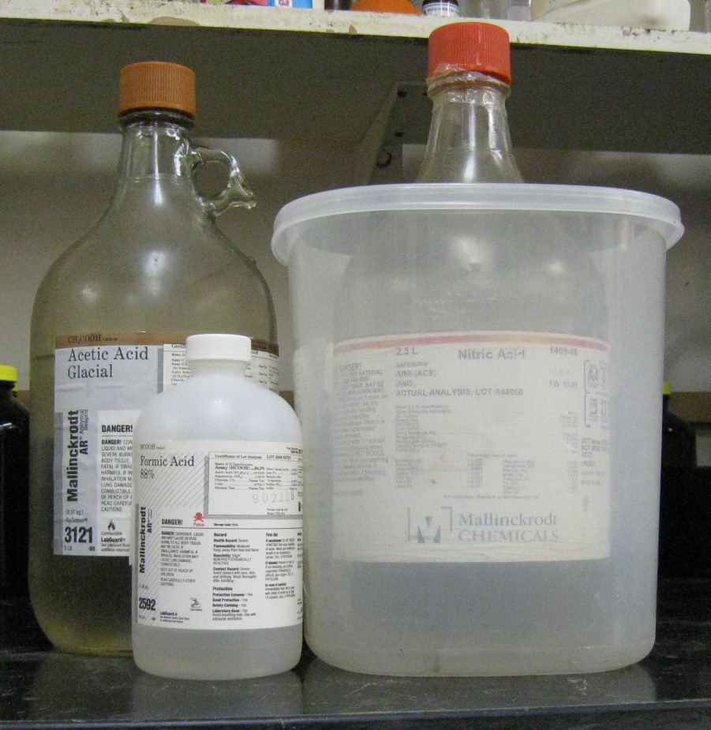
- Opened containers must be carefully resealed and kept upright to prevent leakage.
- Keep away from sources of ignition. Avoid heat and shock or friction when handling.
- Store in original container. Acids should not be stored in metal containers.
- Keep away from incompatible materials, including alkaline agents and oxidizers. Incompatibilities will be noted in Section 10 of the SDS, “Stability and Reactivity”.
Organic acid
Oxidizing acid
- Use in the smallest practical quantities for the experiment being performed.
- Inventory the chemical in MyChem and ensure the manufacturer’s SDS is linked to the inventory entry. Keep a printed or electronic copy of the SDS readily available to all personnel working in the laboratory at all times.
- Containers should remain closed when not in use.
- Label new containers appropriately. Label should indicate the name of the chemical(s) in the container. Avoid using chemical abbreviations (acceptable if a legend is present in the lab) and formulae.
- Containers should be in good condition and compatible with the material.
- Transport Trifluoroacetic acid in secondary containment, such as polyethylene or other non-reactive acid/solvent bottle carrier.

Section 5 – Spill and Accident Procedures
Assess the extent of danger. Help contaminated or injured persons. Evacuate the spill area and ensure others are aware of a spill. Avoid breathing vapors. If there is an imminent threat of a fire, pull the nearest fire alarm station to evacuate the building and dial 911.
If possible, confine the spill to a small area using a spill kit or inert absorbent material. Keep others from entering contaminated area (e.g., use caution tape, barriers, etc.).
For a minor spill (< 500 mL) that does not pose a threat to personnel, contact EH&S at 206.543.0467 during normal business hours (Monday – Friday, 8 AM – 5 PM) for spill cleanup assistance. Use appropriate personal protective equipment and clean-up material for chemical spilled. Double bag spill waste in clear plastic bags and label for chemical waste collection.
For assistance after hours or in the case of a large spill (> 500 mL), dial 911.
If personnel have become exposed, seek medical attention immediately and dial 911 as needed.
If chemical is spilled on body or clothes, remove clothing and rinse body thoroughly in emergency shower for at least 15 minutes. Seek medical attention. Notify supervisor and EH&S immediately.
If chemical is splashed into eyes, immediately rinse eyeball and inner surface of eyelid with water from the emergency eyewash station for 15 minutes by forcibly holding the eye open. Seek medical attention. Notify supervisor and EH&S immediately.
Any spill, exposure or near miss incident requires the involved person or supervisor to complete and submit the Online Accident Reporting System (OARS) form on the EH&S website within 24 hours (certain types of incidents require immediate notification) at oars.ehs.washington.edu.
Section 6 – Waste Disposal Procedures
Store trifluoroacetic acid waste in a closed container that is properly labeled as a hazardous waste. Trifluoroacetic acid waste should be segregated from all incompatibles (e.g. alkalines, oxidizers), and cannot be poured down the drain. Complete an online Chemical Waste Collection Request to arrange for disposal by EH&S; detailed instructions are provided at the following link: http://www.ehs.washington.edu/epowaste/chemwaste.shtm.
Section 7 – Protocol (Additional lab-specific protocol may be added here)
Click here to enter text.
NOTE: Any deviation from this SOP requires approval from the Principal Investigator.

Section 8 – Documentation of Training (signature of all users is required)
Prior to conducting any work with corrosives, the Principal Investigator must ensure that all laboratory personnel receive training on the content of this SOP.

I have read and understand the content of this SOP:
Name | Signature | Date

