INSTRUCTIONS: This Standard Operating Procedure (SOP) template is complete when
1) All form fields have been completed to reflect chemical/workplace-specific information, including adding relevant procedure information, or deleted inapplicable information; and
2) SOP has been signed and dated by the Principal Investigator (PI) or Responsible Party (RP) and relevant personnel.
Use safety data sheets (SDSs) as a resource for chemical-specific information. Text highlighted in gray indicates where information must be added or edited. Delete all instructions in red text and “Draft” watermark after the SOP is approved by the PI or RP.
Methylene Chloride Regulatory Information and Requirements
The use of Methylene Chloride is regulated by the United States Environmental Protection Agency (EPA) under the Toxic Substances Control Act (TSCA) and by Washington Department of Labor & Industries under WAC 296-62-07470. The use of methylene chloride is prohibited except for the allowable uses listed below. Please ensure that your use of methylene chloride is allowable before proceeding. More information can be found on the EPA’s website.
Allowable uses:
1. Domestic manufacturing
2. Import
3. Processing as a reactant
4. Processing in incorporation into formulation, mixture, or reaction product
5. Processing in repackaging
6. Processing in recycling
7. Use as a laboratory chemical
8. Use in paint and coating removers for safety critical, corrosion-sensitive components of aircraft and
spacecraft
9. Use as a bonding agent for solvent welding
10. Industrial and commercial use as a processing aid
11. Use for plastic and rubber products manufacturing
12. Use as a solvent that becomes part of a formulation or mixture where the formulation or mixture will be used inside a manufacturing process and the solvent (methylene chloride) will be reclaimed
13. Disposal
Completion of this SOP template fulfils the EPA’s exposure control plan requirement. The goal of implementing the exposure control plan is to identify exposure controls and how the hierarchy of controls is implemented to reduce inhalational exposures below applicable exposure limits. All methylene chloride users must review and sign your completed SOP.
In addition to this SOP, users of methylene chloride may be required to participate in exposure monitoring as required under the methylene chloride TSCA rules. You must contact EH&S at ehsdept@uw.edu if you have not yet had exposure monitoring conducted by EH&S.

Standard Operating Procedure
Methylene Chloride / Dichloromethane
Section 1 – Workplace-Specific Information
Chemical(s) covered by this SOP:
Building/Room(s) covered by this SOP:
Unit or department:
Principal Investigator Name:
Principal Investigator Signature/Date:
This SOP was created by (if not PI or RP):
Name/Title/Date/Signature
Important Definitions
- Action level: a concentration designated in regulations for a specific substance, calculated as an eight (8)-hour time-weighted average, which initiates certain required activities such as exposure monitoring and medical surveillance.
- Permissible exposure limit (PEL)/ Existing Chemical Exposure Limit (ECEL): the exposure limit designated in regulations for a specific substance, calculated as an eight (8)-hour time-weighted average, that should not be exceeded in a workday.
- Short-term exposure limit (STEL): the airborne concentration designates regulations for a specific substance that should not be exceeded in a 15 minute period.

Section 2 – Hazards
REQUIRED -Identify the stock chemicals, intermediates, final compounds and wastes involved in your work.
Methylene chloride or dichloromethane (DCM) is a halogenated organic compound commonly used as an extraction solvent e.g., thin-layer chromatography application for isolating organic compounds. It is also commonly used in acrylic solvent welding. Methylene chloride is federally regulated by the EPA under TSCA. This SOP documents the safe use of methylene chloride including the minimization of exposures via inhalation due to methylene chloride’s high volatility and in accordance with EPA regulations.
Exposure Limits:
EPA ECEL (8-hour TWA): 2 ppm
EPA action level (8-hour TWA): 1 ppm
EPA STEL (15-minute TWA): 16 ppm
The EPA exposure limits are more protective than Washington State exposure limits. The more protective EPA exposure limits must be adhered to.
Acute effects: Very hazardous in case of skin/eye contact, ingestion, or inhalation. In case of ingestion, methylene chloride may cause irritation of the gastrointestinal tract with vomiting. If vomiting results in aspiration, chemical pneumonia could follow. Absorption through gastrointestinal tract may produce symptoms of central nervous system depression ranging from light-headedness to unconsciousness. Skin contact can result in irritation and redness and may be absorbed into the bloodstream. Prolonged contact may cause chemical burns and neuropathy. Inflammation of the eye is characterized by redness, watering, and itching. Eye contact may cause eye damage.
Chronic effects: Methylene chloride may cause cancer in humans. Additional chronic effects may include headache, mental confusion, depression, liver effects, kidney effects, bronchitis, loss of appetite, nausea, lack of balance, and visual disturbances.
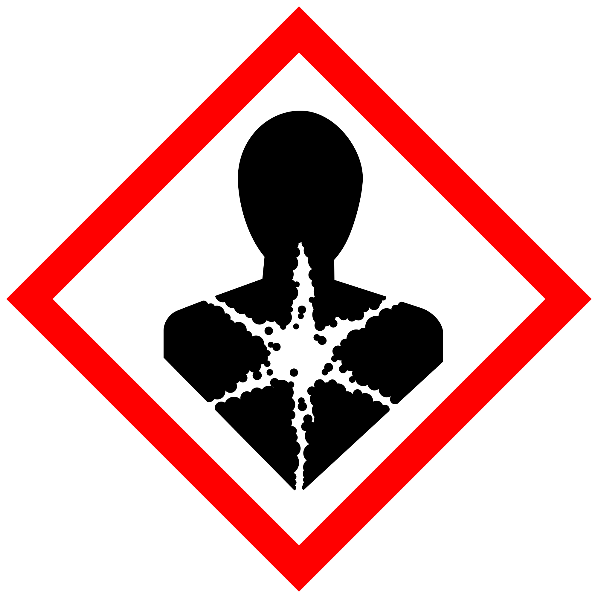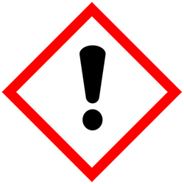
Section 3 – Control Measures
The EPA requires that groups evaluate the following types of control methods to limit exposure to methylene chloride. For each type of control measure, detail how it will be implemented or explain why that type of control cannot be used.
Elimination/Substitution: Determine if the use of methylene chloride can be eliminated or if another chemical can be used in place of methylene chloride.
REQUIRED: explain why complete elimination/substitution of methylene chloride is not feasible.
Engineering Controls: Local exhaust ventilation is the best control to reduce vapors released during use of methylene chloride. Wherever possible, the use of methylene chloride should be conducted in a properly functioning chemical fume hood which has been approved and tested by EH&S. Alternative solutions can include direct connected exhaust systems designed to capture the vapors at the point of release and/or closed-system operations designed to prevent the release of vapors.
REQUIRED - Insert descriptions of lab-specific engineering or ventilation controls used to reduce chemical exposures (e.g.,fume hoods, snorkels, glove boxes, reverse flow laminar benches, biosafety cabinets, etc.) or specific equipment safety features.
Administrative Controls: These control measures include changing the way that people work around methylene chloride. This could include reducing the exposure to methylene chloride by reducing the duration, frequency, or intensity of contact.
Explain what practices will be implemented to limit methylene chloride exposure or explain why changing work practices is not feasible.
Hygiene Measures: Avoid contact with skin, eyes, and clothing. If methylene chloride comes into contact with any PPE, the PPE shall be immediately removed and discarded properly. Any potentially exposed body parts should be washed immediately. Wash hands after removing PPE before breaking and immediately after handling the chemical.
Personal Protective Equipment: The following required controls are to protect the worker from exposure using PPE. Additionally, staff must receive training on how to inspect and use PPE. If there are any questions about how to implement these protection measures, contact EH&S at (206) 543-7262.
Hand Protection: The most common gloves found in campus labs and shops (nitrile, neoprene and latex) are generally not recommended for use with methylene chloride due to the ease with which it permeates through the glove material. The required glove materials are dependent on the situation in which they will be used. This is outlined in a chart below to aid in selection. Gloves must be inspected prior to use. Gloves must be handled in accordance with the manufacturer’s instructions. Use proper glove removal technique (without touching glove's outer surface) to avoid skin contact with this product. Wash and dry hands after use.
Glove Selection Guide
Situation | Requirement | Rationale
Low splash potential (for example pipetting and pouring small volumes) | Personnel must wear two layers of nitrile gloves (palm thickness of 5 mil or greater). Personnel must immediately remove the outer glove layer upon contact with methylene chloride. Personnel must also assess the integrity of the inner layer and remove if degradation is apparent. | Nitrile gloves provide very little protection against methylene chloride, with permeation times of one minute or less for 5 mil thickness nitrile gloves.
Moderate to high splash potential (for example pouring larger volumes from one container to another) | Personnel must wear Viton butyl rubber gloves. It is recommended that an outer layer of nitrile gloves be worn overtop the Viton butyl. Personnel should remove and replace the outer glove layer upon contact with methylene chloride. | Viton butyl provides adequate splash protection with permeation breakthrough times generally between 30-60 minutes.
Spill cleanup or sustained contact or immersion of gloves | Personnel must wear polyvinyl alcohol (PVA) gloves or Silver Shield® gloves. If using Silver Shield® gloves, nitrile gloves can be worn as an outer layer to improve dexterity. | PVA gloves afford some of the greatest level protection against methylene chloride and other chlorinated solvents. Note that PVA is water soluble and must not be used with aqueous solutions or exposed to water.  Silver Shield® gloves are a laminate glove including ethylene vinyl alcohol and polyethylene and provide excellent protection against methylene chloride and many other chemicals (including aqueous solutions).
REQUIRED - Insert the lab-specific gloves or glove combination that are required. When possible, include the exact manufacturer and model information.
Eye Protection: ANSI-approved safety glasses with side shields are required where there is low splash potential. Where there is moderate to high splash potential, tight fitting safety goggles are required.
REQUIRED - Specify minimum eye protection required (splash goggles, safety glasses, safety goggles, face shields).
Skin and Body Protection: Laboratory coats or other chemical protective garments must be worn and be appropriately sized for the individual when handling in a manner that could result in bodily exposure. Personnel must also wear full-length pants, or equivalent, and close-toed shoes. Full-length pants and close-toed shoes must be worn at all times by all individuals that are occupying laboratories and shop areas. The area of skin between the shoe and ankle must not be exposed.
REQUIRED - Specify type of skin and body protection to be used.
Additional Controls, if necessary:
Respiratory Protection: Filtering air purifying respirators are not protective against methylene chloride vapors. Only supplied air or self-contained breathing apparatus systems provide adequate protection to methylene chloride vapors. EH&S will generally not approve of supplied air or self-contained breathing apparatus systems for methylene chloride and require that other controls be implemented prior to respirator consideration. Contact uwresp@uw.edu for additional information.
Describe any additional controls in use.
Section 4 – Special Handling and Storage Requirements
- Avoid contact with skin and eyes, and do not inhale.
- Do not store in aluminum containers. Methylene chloride reacts with aluminum and its alloys.
- Keep containers tightly closed. Store in a cool, dry, and well-ventilated area.
- Keep away from incompatible substances such as oxidizing agents, acids, and amines.
- Use in the smallest practical quantities for the experiment being performed.
- Work must be conducted in a properly functioning chemical fume hood or glove box. You must reach out to EH&S at 206.543.7388 if using methylene chloride in a fume hood is not possible to explore alternative solutions.
- Do not store methylene chloride in vented squeeze bottles.
- Containers must remain closed when not in use.
- Containers must be labeled appropriately. Label must indicate the name of the chemical(s) in the container. Avoid using chemical abbreviations and formulae.
- Containers must be in good condition and compatible with the material.

Section 5 – Spill and Accident Procedures
Exposures: If a person is injured, exposed, or suspected of being exposed to methylene chloride, follow the procedures detailed on the Exposure Response Poster and detailed here. If skin is exposed to methylene chloride, remove contaminated clothing and shoes, rinse for 15 minutes in the safety shower. Send someone to call 911 as soon as possible. If eyes are exposed, flush eyes for 15 minutes in the eyewash and send someone to call 911 as soon as possible. If methylene chloride is inhaled, remove it to fresh air and call 911. Bring Safety Data Sheet (SDS) with you to show medical personnel.
Procedures for spills inside a fume hood or glove box:
- Spills inside a fume hood or glovebox can typically be cleaned up by trained personnel.
- Personnel must wear a lab coat or smock, safety goggles, polyvinyl alcohol (PVA) gloves or Silver Shield® gloves.
- Wipe up spilled liquids with absorbent pads.
- Clean the spill area thoroughly with detergent solution followed by clean water.
- Double bag all waste in plastic bags labeled with a hazardous waste label that reads "methylene chloride spill debris." Complete either an Online Chemical Waste Collection Request or a Chemical Collection Request Form found on the EH&S website. Email the form to chmwaste@uw.edu
Procedures for spills outside of fume hood or glove box:
- Spills outside of fume hoods or gloveboxes may rapidly generate vapors above the methylene chloride exposure limits.
- Evacuate the area and restrict access (e.g., use caution tape, barriers, etc.). Attend to injured or exposed persons using emergency shower or eyewash. Follow procedures listed above under Exposures.
- As soon as possible, report the spill in a safe area by notifying EH&S (during business hours (M-F/8-5) 206-543-0467, outside business hours 911* on a campus phone). Tell them that a methylene chloride spill has occurred. EH&S may recommend staying out of the room until the spill has evaporated and exposure monitoring has been completed to clear the area, or they may arrange for a spill cleanup contractor depending on the size of the spill. Notify your supervisor.
- Be prepared to provide the following information:
- Name and phone number of knowledgeable person that can be contacted
- Name of chemical spilled, concentration and amount spilled, liquid or solid type spill
- Number of injured, if any
- Location of spill
This information can also be used in reporting to the Emergency Department (ED) after potential exposure.
Report all spills and injuries via the EH&S Online Accident Reporting System (OARS) within 24 hours. Notify EH&S immediately (after first aid/medical care/emergency services) if a workplace incident involves any of the following since EH&S reports these to regulatory and funding agencies:
- In-patient hospitalization, amputation, loss of an eye, or fatality
- Recombinant/synthetic DNA/RNA exposure or spill
- Radioactive material spill, exposure, accidental exposure from a radiation producing device or laser
- Fire
REQUIRED - Insert descriptions of any specialized spill clean up procedures for materials used in this SOP. Additional details of lab-specific spill cleanup should be provided if applicable.
Describe how spills or accidental releases should be handled and by whom.
Clean up spills using contents of the laboratory spill kit: Note location of spill kit. Describe specific types of spill clean-up materials required.

Section 6 – Waste Disposal Procedures
Describe specific waste disposal procedures for all waste streams generated with methylene chloride. Include appropriate containment practices, storage locations, and any specific storage or handling practices.
Refer to the SDS and UW Laboratory Safety Manual, Section 3 for guidance on waste handling, labeling, accumulation, storage and pickup.
Per UW Administrative Policy Statement 11.2, the University of Washington Environmental Health & Safety Department has full responsibility for collection of hazardous waste for the University, all its campuses, and off-site locations; University laboratories cannot contract with an outside vendor to collect hazardous waste.

Be aware that many laboratory accidents happen from inadvertent disposal of incompatible wastes into the same waste container. Therefore, identify different waste streams as appropriate.

Separate non-halogenated solvent waste from halogenated solvent waste to the extent possible.

Accumulate waste at the point of generation in a sturdy, [compatible container], with a securely closable/screw‐top lid.

Manage chemical and hazardous chemical waste separately from other waste streams such as biohazardous waste. Never autoclave chemical waste because it can produce hazardous chemical vapors, aerosols, and explosive reactions.

All chemical waste containers must be labeled with a UW Hazardous Waste Label. Refer to How to Label Chemical Waste Containers.

To request a collection of chemical waste, submit a form on the Chemical Waste Disposal webpage on the EH&S website or directly in MyChem inventory. Contact EH&S at 206.616.5835 or chmwaste@uw.edu with questions.

Work area decontamination procedures as appropriate for the chemical in use should be followed.

REQUIRED - Insert descriptions of decontamination procedures for equipment, glassware, and controlled areas (e.g., glove boxes, restricted access hoods, perchloric/hot acid fume hoods, or designated portions of the laboratory) where this/these chemical(s) is/are used.

Visit the Hazardous Material Disposal and Recycling webpage on the EH&S website for information on disposing materials.

Section 7 – Process/Protocol
Insert or attach detailed laboratory-specific procedures for the process, hazardous chemical(s), or hazard class. You may also include any relevant supporting resources such as journal citations, etc. that are applicable.
Refer to Section 2 of the UW Laboratory Safety Manual on the EH&S website for additional guidance on chemical management.
NOTE: Any deviation from this SOP requires approval from Principal Investigator.

Section 8 – Approvals required
All staff working with methylene chloride products must be trained on this SOP prior to starting work. They must also review the appropriate SDSs, and they must be readily available in the workplace. All training must be documented and maintained by the PI, RP, or their designee.
Describe any requirements for obtaining authorization before use of the chemical for the procedure, operation, or activity can be performed.
Examples:
- A worker must have [specific training] documented before performing the procedure described for the first time.
- Other authorizations required before a person can independently perform a process using a methylene chloride.

Section 10 – Decontamination
Include work area decontamination procedures as appropriate for the chemical in use:
REQUIRED - Insert descriptions of decontamination procedures for equipment, glassware, controlled areas (e.g., glove boxes, restricted access hoods, perchloric/hot acid fume hoods, designated laboratory areas), include cleaning solutions and materials.

Section 11 – Designated area

REQUIRED - Identify specific areas where methylene chloride may be used (e.g., glove boxes, restricted access hoods, perchloric/hot acid fume hoods, or designated portions of the laboratory).

Section 12 – Documentation of training (signature of all users is required)
- Prior to using substances included in this SOP, personnel must be trained on the hazards described in this SOP, how to protect themselves from the hazards, and emergency procedures.
- Ready access to this SOP and to a Safety Data Sheet for each hazardous material described in the SOP must be made available in the space(s) where these substances are used.
- The PI or RP must ensure that their laboratory personnel have attended appropriate safety training (and refresher training where applicable).
- Training must be repeated following any revision to the content of this SOP.
- Training must be documented. This training sheet is provided as one option; other forms of training documentation (including electronic) are acceptable, but records must be accessible and immediately available upon request.
I have read and understand the content of this SOP:
Name | Signature | Date

