INSTRUCTIONS: This is an SOP template; it is complete when
1) All form fields have been completed to reflect chemical/lab-specific information, including adding relevant procedure information, or deleted inapplicable information; and
2) SOP has been signed and dated by the PI and relevant lab personnel.
Use safety data sheets (SDSs) as a resource for chemical-specific information. Text highlighted in gray indicates where information should be added or edited. Delete all instructions in red text and “Draft” watermark after the SOP is approved by PI.
Standard Operating Procedure
Nitric Acid
Section 1 – Lab-Specific Information
Chemical(s) covered by this SOP:
Building/Room(s) covered by this SOP:
Unit or department:
Principal Investigator Name:
Principal Investigator Signature/Date:
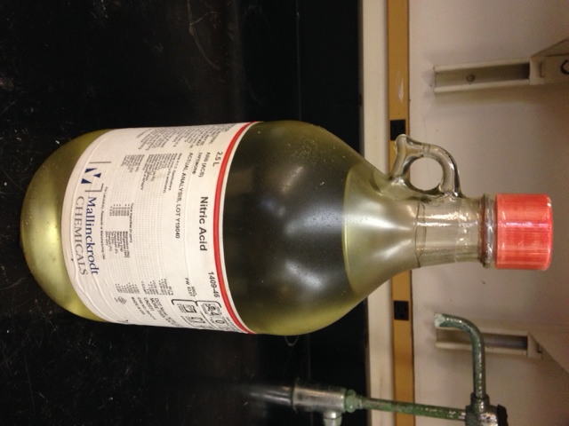
Section 2 – Hazards
Nitric acid is an oxidizer that may intensify fires. Fire conditions may cause the formation of hazardous nitrogen oxides. It can react violently with organic chemicals such as organic solvents. Nitric acid may be harmful if inhaled, ingested, or absorbed through the skin. It is extremely destructive to the tissue of the mucous membranes and upper respiratory tract. It causes severe skin and eye burns and may cause blindness and permanent eye damage. Inhalation may cause spasms, inflammation and edema of the bronchi or larynx. Other symptoms include burning sensation, coughing, wheezing, shortness of breath, headache, nausea, vomiting, and pulmonary edema. Effects may be delayed. Large doses may conversion of hemoglobin to methemoglobin, producing cyanosis or a drastic fall in blood pressure, leading to collapse, coma, and possibly death. Chronic exposure may cause erosion of the teeth, jaw necrosis, and kidney damage.
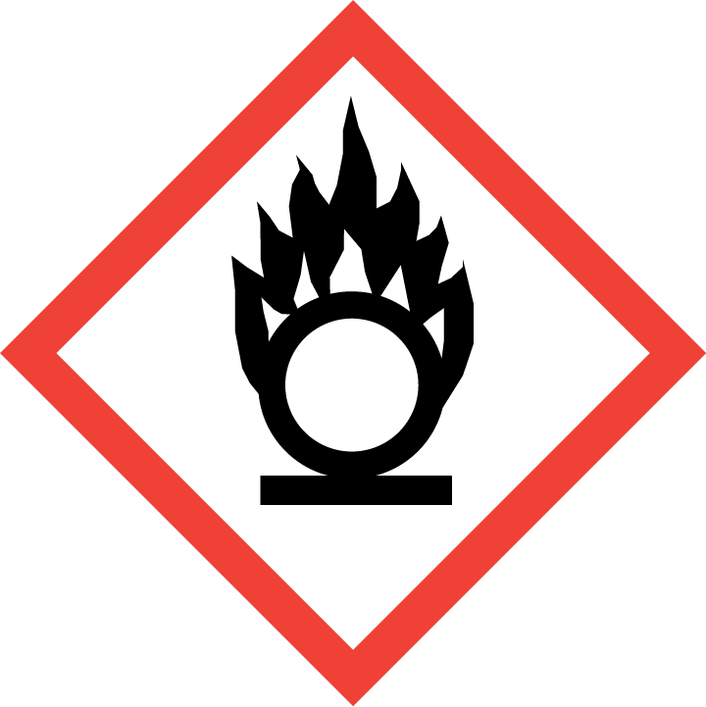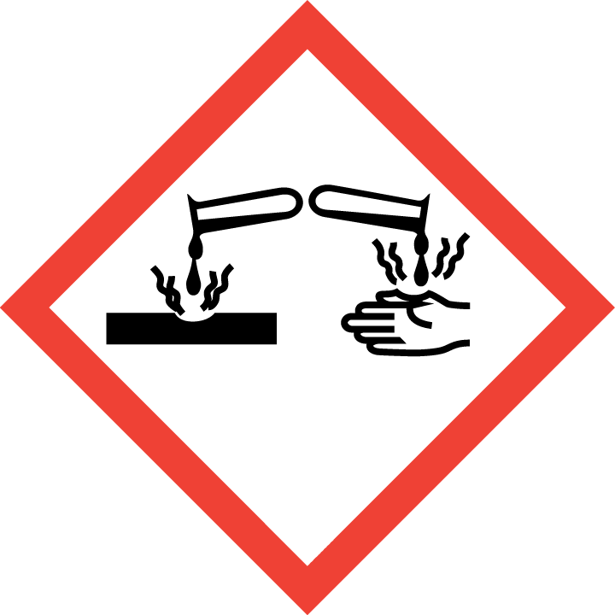

Section 3 – Engineering Controls and Personal Protective Equipment (PPE)
Engineering Controls: Use of corrosive materials should be conducted in a properly functioning chemical fume hood whenever possible. The chemical fume hood must be approved for use by EH&S.
Hygiene Measures: Avoid contact with skin, eyes, and clothing. Wash hands before breaks and immediately after handling the product.
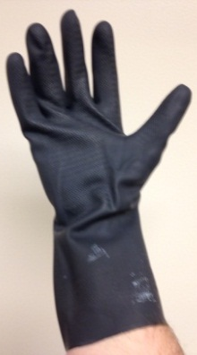
Hand Protection: Two-sets of chemical-resistant gloves (e.g., nitrile) should be worn (“double-gloving”). A heavy-duty glove, such as butyl rubber, Viton, or equivalent, is recommended, especially when handling concentrated nitric acid or more than 1L. Nitrile gloves are NOT recommended for concentrated (>70%) nitric acid according to the Ansell Chemical Resistance Guide. NOTE: Consult with your preferred glove manufacturer to ensure that the gloves you plan on using are compatible with the specific chemical being used.
Eye Protection: ANSI approved properly fitting safety glasses or chemical splash goggles are required. A face shield is also recommended
Skin and Body Protection: Laboratory coats must be worn and be appropriately sized for the individual and buttoned to their full length. Personnel must also wear full length pants, or equivalent, and close-toed shoes. Full length pants and close-toed shoes must be worn at all times by all individuals that are occupying the laboratory area. The area of skin between the shoe and ankle must not be exposed.
Respiratory Protection: Respirators should be used as a last line of defense (i.e., after engineering and administrative controls have been exhausted), when Permissible Exposure Limit (PEL) has been exceeded, when there is a possibility that PEL will be exceeded, or as PPE in the event of a chemical spill clean-up process. If this activity is necessary, contact EH&S at 206.616.3777 so a respiratory protection analysis can be performed.
Section 4 – Special Handling and Storage Requirements
- Avoid contact with skin, eyes, and clothing.
- Always use inside a properly functioning chemical fume hood.
- Note: In case you need to dilute the concentration of nitric acid, always add acid to water.
- Keep container upright and tightly closed in acid storage cabinet.
- Keep container within a secondary containment (Nalgene/ polypropylene tray or tub). Store in original container away from direct sunlight.
- Keep away from incompatible materials: alkali metals, reducing agents, cyanides, aldehydes, powdered metals, ammonia, and acetic anhydride, acids, and all organic materials including organic solvents.
- Do not store in the top most shelf of the storage cabinet. In general, do not store chemicals at or above eye level.
- Use in the smallest practical quantities for the experiment being performed. Make up concentrated solutions in amounts that will be used up in the workshift/day.
- Inspect containers monthly for discoloration. Submit a Chemical Waste Collection Request for any discolored nitric acid.
- Containers should remain closed when not in use.
- Do not over purchase; only a minimum amount of nitric acid should be stored in the laboratory
Section 5 – Spill and Accident Procedures
If skin is exposed to nitric acid, remove contaminated clothing and shoes, rinse for 15 minutes in the safety shower and wash with soap. Send someone to call 911 as soon as possible. If eye is exposed to nitric acid, call 911 as soon as possible, remove contact lenses, and flush eyes for 15 minutes in the eye wash; continue rinsing eyes during transport to hospital. If nitric acid is inhaled, remove to fresh air and call 911. Bring Safety Data Sheet (SDS) with you to show medical personnel.
Immediately evacuate area if fumes present a serious health risk and ensure others are aware of the spill. During normal business hours (Monday – Friday, 8 AM – 5 PM), call EH&S at 206.543.0467 for further assistance. If it is after hours, call 911 for further assistance. If possible, confine the spill to a small area using a spill kit or absorbent material. Keep others from entering contaminated area (e.g., use caution tape, barriers, etc.).
For spills < 1 Liter, use appropriate personal protective equipment listed above and clean-up material for chemical spilled. Neutralize the residue with a dilute solution of sodium carbonate. Double bag and securely fasten spill materials. Label as hazardous waste.
For spills > 1 Liter, call EH&S at 206.543.0467 for further assistance during normal business hours (Monday – Friday, 8 AM – 5 PM). If it is after hours, call 911 for further assistance.
Report the spill via the EH&S Online Accident Reporting System (OARS).
Section 6 – Waste Disposal Procedures
Store hazardous waste in closed containers that are properly labeled, and in a designated area (acids cabinet is recommended). Nitric acid waste should be segregated from all incompatible chemicals, including other acids. Complete a Chemical Waste Collection Request Form to arrange for disposal by EH&S; detailed instructions are provided at the following link: http://www.ehs.washington.edu/epowaste/chemwaste.shtm.
Section 7 – Protocol (Add lab specific Protocol/Procedure here)
Click here to enter text.
NOTE: Any deviation from this SOP requires approval from PI.
Section 8 – Documentation of Training (signature of all users is required)
Prior to conducting any work with nitric acid, the Principal Investigator must ensure that all laboratory personnel receive training on the content of this SOP.

I have read and understand the content of this SOP:
Name | Signature | Date

