INSTRUCTIONS: This is an SOP template; it is complete when
1) All form fields have been completed to reflect chemical/lab-specific information, including adding relevant procedure information, or deleted inapplicable information; and
2) SOP has been signed and dated by the PI and relevant lab personnel.
Use safety data sheets (SDSs) as a resource for chemical-specific information. Text highlighted in gray indicates where information should be added or edited. Delete all instructions in red text and “Draft” watermark after the SOP is approved by PI.
Standard Operating Procedure
Hydrogen Peroxide
Print a copy and insert into your Lab-Specific Chemical Hygiene Plan.

Section 1 – Lab-Specific Information
Building/Room(s) covered by this SOP:
Unit or department:
Principal Investigator Name:
Principal Investigator Signature/Date:
This SOP was created by (if not PI):
Name/Title/Date/Signature:
Section 2 – Hazards
Hydrogen peroxide is a strong oxidizer that has a potential to cause a fire or explosion in contact with incompatible materials such as combustibles (e.g., wood, paper, organic solvents). It is corrosive and light-sensitive. It is toxic if swallowed and corrosive to the eyes and skin. Prolonged exposure may cause dermatitis. 30% hydrogen peroxide requires special storage and handling procedures. It is a very strong oxidizing agent and severely corrosive to skin, eyes, and respiratory tract. Many common substances, including iron and other transition metals, will catalyze the decomposition to product copious amounts of oxygen gas and heat. The 30% solution is a dangerous fire and explosion risk—do not heat.
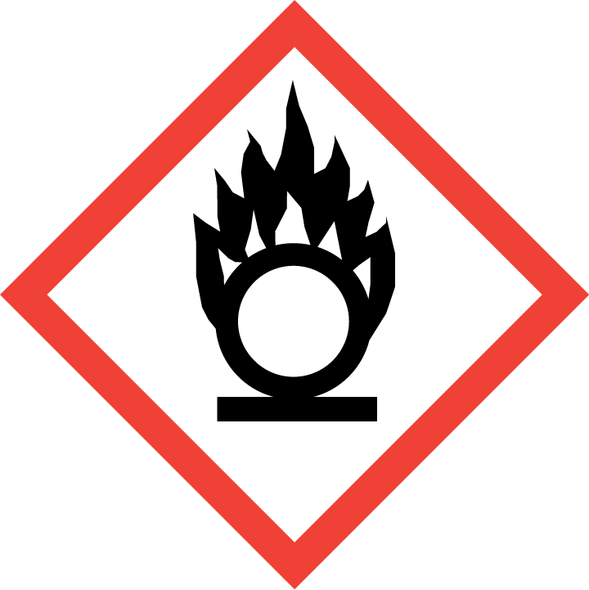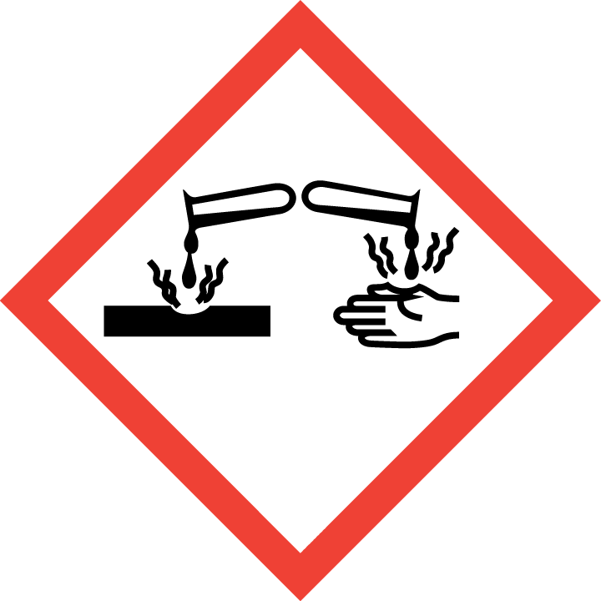

Section 3 – Engineering and Personal Protective Equipment (PPE)
Engineering Controls: Use of hydrogen peroxide should be conducted in a properly functioning chemical fume hood whenever possible. The chemical fume hood must be approved for use by EH&S.
Hygiene Measures: Avoid contact with skin, eyes, and clothing. Wash hands before breaks and immediately after handling the product.
Hand Protection: Chemical-resistant gloves must be worn, nitrile gloves are recommended for low volume applications. Wearing two pairs of nitrile gloves is recommended. For high volume applications, disposable gloves are not appropriate; a heavy-duty glove is required such as butyl rubber, Viton, or equivalent. NOTE: Consult with your preferred glove manufacturer to ensure that the gloves you plan on using are compatible with the specific chemical being used.
Eye Protection: ANSI approved properly fitting safety glasses or chemical splash goggles are required. A face shield may also be appropriate depending on the specific application.
Skin and Body Protection: Laboratory coats must be worn and be appropriately sized for the individual and buttoned to their full length. For high volume applications, additional PPE such as a chemical-resistant apron may be required. Personnel must also wear full length pants, or equivalent, and close-toed shoes. Full length pants and close-toed shoes must be worn at all times by all individuals that are occupying the laboratory area. The area of skin between the shoe and ankle must not be exposed.
Respiratory Protection: If hydrogen peroxide solution is being used outside of a chemical fume hood, respiratory protection may be required. If this activity is necessary, contact EH&S at 206.543.7388 so a respiratory protection analysis can be performed.
Vent

Section 4 – Special Handling and Storage Requirements
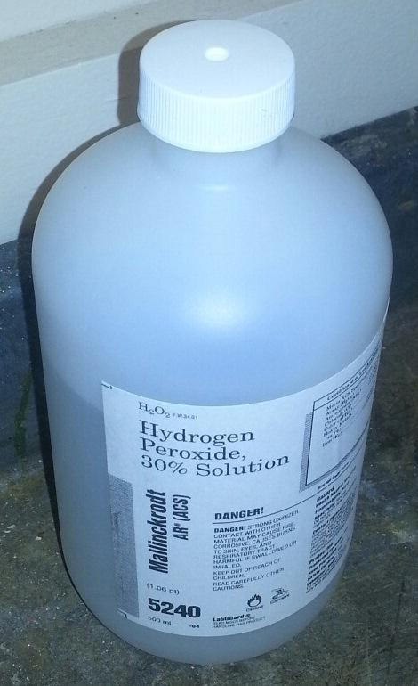
- Avoid contact with skin, eyes, and clothing. Avoid inhalation or ingestion.
- Hydrogen peroxide solutions greater than 10% should be kept in their original container with the manufacturer cap that allows the container to vent oxygen while in storage as shown in the picture to the right.
- Do not store hydrogen peroxide solutions greater than 10% in glass containers; only plastic containers should be used for storage.
- The 30% solution is a dangerous fire and explosion risk—do not heat.
- Keep container tightly closed in a dry and well-ventilated area. Opened containers must be carefully resealed and kept upright to prevent leakage.
- Recommended storage temperature is 2 – 8 ºC. A flammable-proof refrigerator is required for this.
- Do not over purchase; only purchase what can be safely stored in the laboratory.
- Keep container upright and tightly closed in a dry and well-ventilated place.
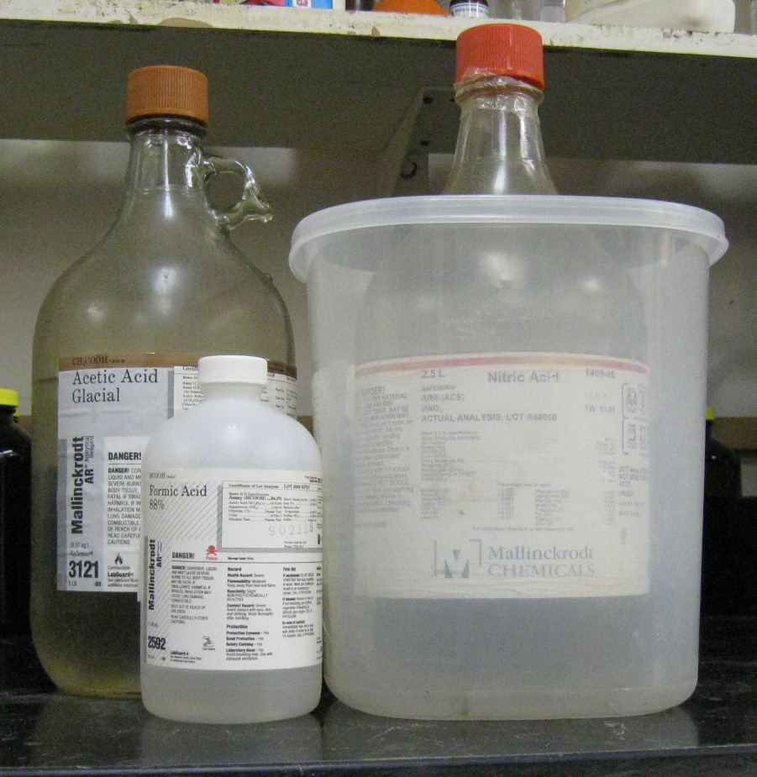
- Opened containers must be carefully resealed and kept upright to prevent leakage.
- Keep away from incompatible materials. Store away from combustible materials. Do not store on wooden shelves. Store away from all organic compounds, including organic solvents. Keep away from iron and other transition metals; hydrogen peroxide will catalyze their decomposition to produce copious amounts of oxygen gas and heat.
Organic acid
Oxidizing acid
- Use in the smallest practical quantities for the experiment being performed.
- Make a current copy of the SDS for the solution being used available to all personnel working in the laboratory at all times.
- Containers should remain closed when not in use.
- Label new containers appropriately. Label should indicate the name of the chemical(s) in the container. Avoid using chemical abbreviations (acceptable if a legend is present in the lab) and formulae.
- Containers should be in good condition and compatible with the material.
- Transport all corrosives in secondary containment, such as polyethylene or other non-reactive acid/solvent bottle carrier.

Section 5 – Spill and Accident Procedures
Immediately evacuate area and ensure others are aware of the spill. If there is an imminent threat of a fire, pull the nearest fire alarm station to evacuate the building and dial 911. If personnel have become exposed and need medical assistance, dial 911. If the spill is minor and does not pose a threat to personnel, contact EH&S at 206.543.0467 during normal business hours (Monday – Friday, 8 AM – 5 PM) for spill cleanup assistance (dial 911 if spill occurs after hours and assistance is needed).
Section 6 – Waste Disposal Procedures
Store hazardous waste in closed containers that are properly labeled, and in a designated area area (flammable cabinet is recommended). No oxidizers are permitted to be poured down the drain. Complete a Chemical Waste Collection Request Form to arrange for disposal by EH&S; detailed instructions are provided at the following link: http://www.ehs.washington.edu/epowaste/chemwaste.shtm.
Section 7 – Protocol (Additional lab protocol may be added here)
Click here to enter text.
NOTE: Any deviation from this SOP requires approval from Principal Investigator.

Section 8 – Documentation of Training (signature of all users is required)
Prior to conducting any work with hydrogen peroxide, the Principal Investigator must ensure that all laboratory personnel receive training on the content of this SOP.
I have read and understand the content of this SOP:
Name | Signature | Date

